Test Case: tc002_SPX_Dev5_Crear_Requisicion_Spot_Tipo_Cobro_Project
Step 1 - Enter username and password and click to button Enter: Credentials Entered
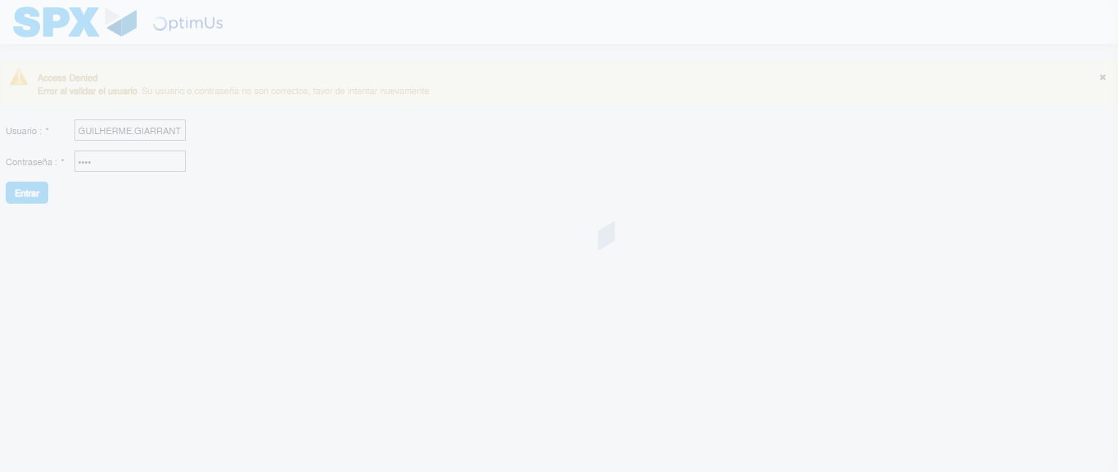Image file-name: QC_Testing-tc002_SPX_Dev5_Crear_Requisicion_Spot_Tipo_Cobro_Project-1784309876250

Step 2 - Select to UEN and Access to Spot Buy Requisitions : UEN Correctly selected and Correct access
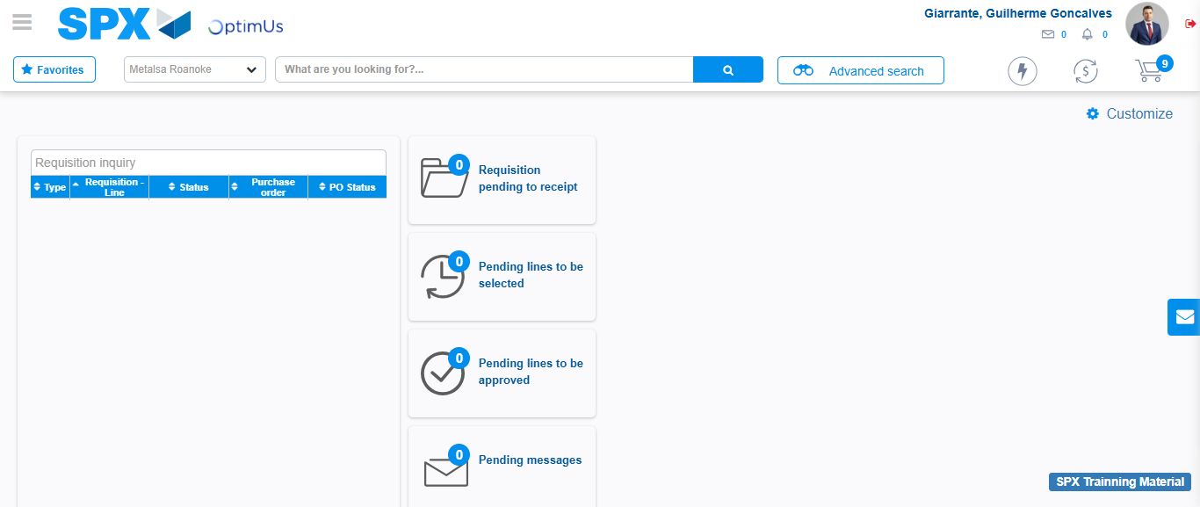Image file-name: QC_Testing-tc002_SPX_Dev5_Crear_Requisicion_Spot_Tipo_Cobro_Project-1784309938927

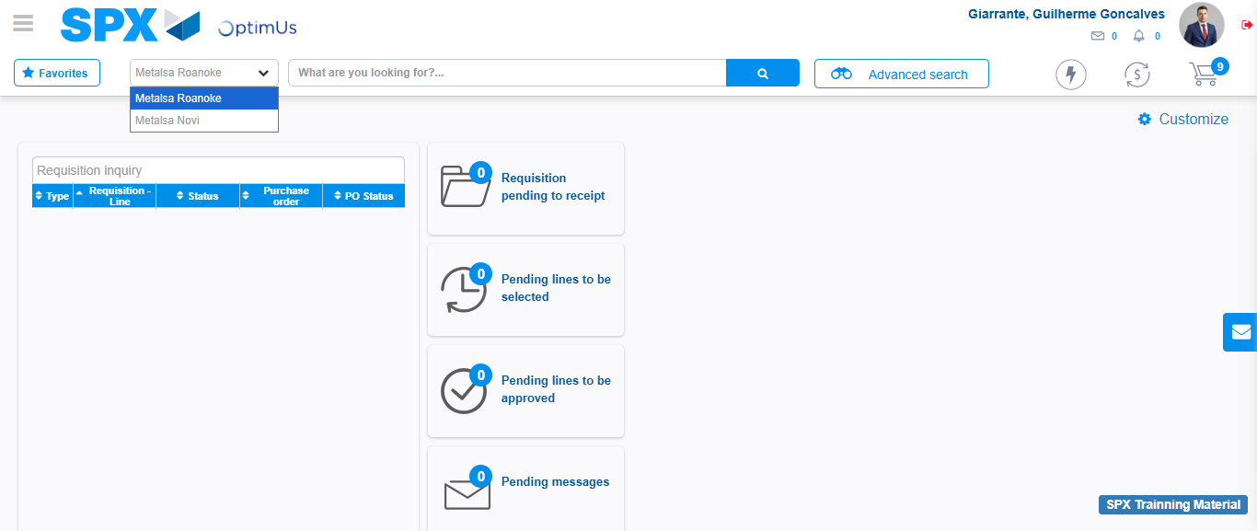Image file-name: QC_Testing-tc002_SPX_Dev5_Crear_Requisicion_Spot_Tipo_Cobro_Project-1784309941966

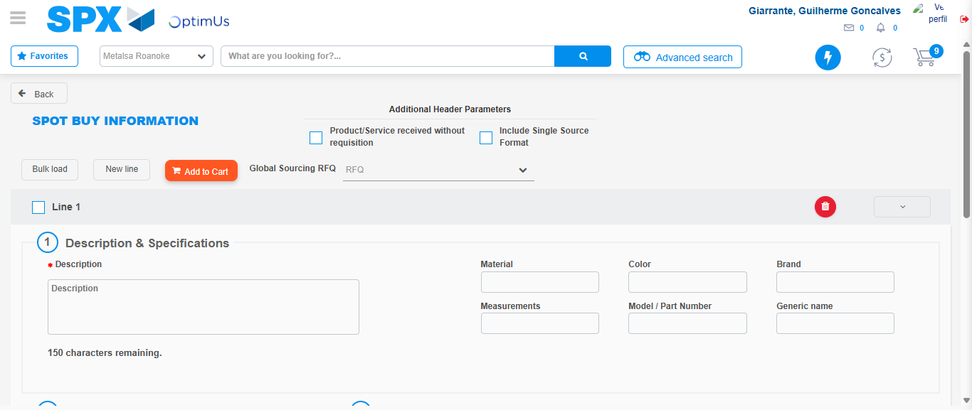Image file-name: QC_Testing-tc002_SPX_Dev5_Crear_Requisicion_Spot_Tipo_Cobro_Project-1784309951386

Step 3 - Data Capture Spot Buy Requisition: Data captured correctly
Image file-name: QC_Testing-tc002_SPX_Dev5_Crear_Requisicion_Spot_Tipo_Cobro_Project-1784309951793

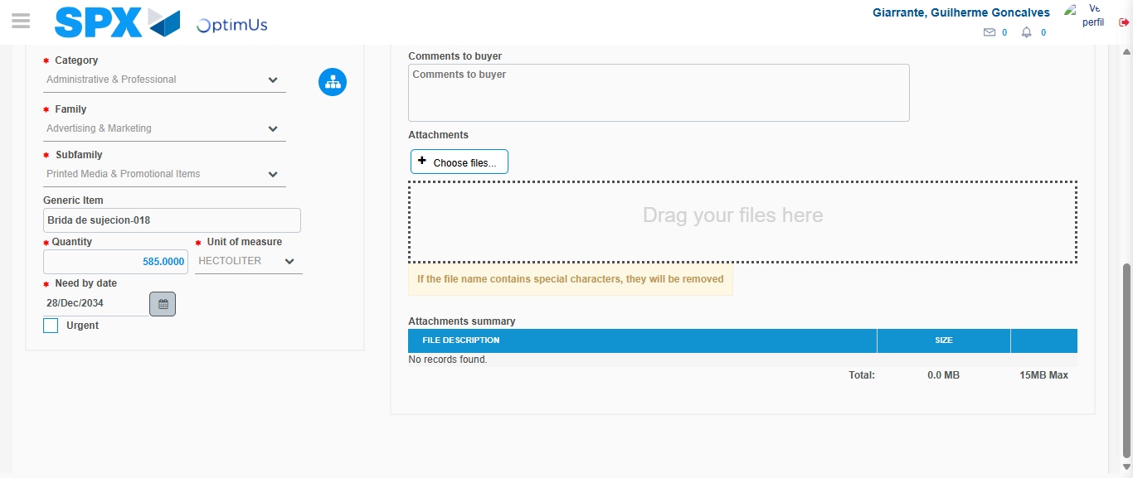Image file-name: QC_Testing-tc002_SPX_Dev5_Crear_Requisicion_Spot_Tipo_Cobro_Project-1784309969209

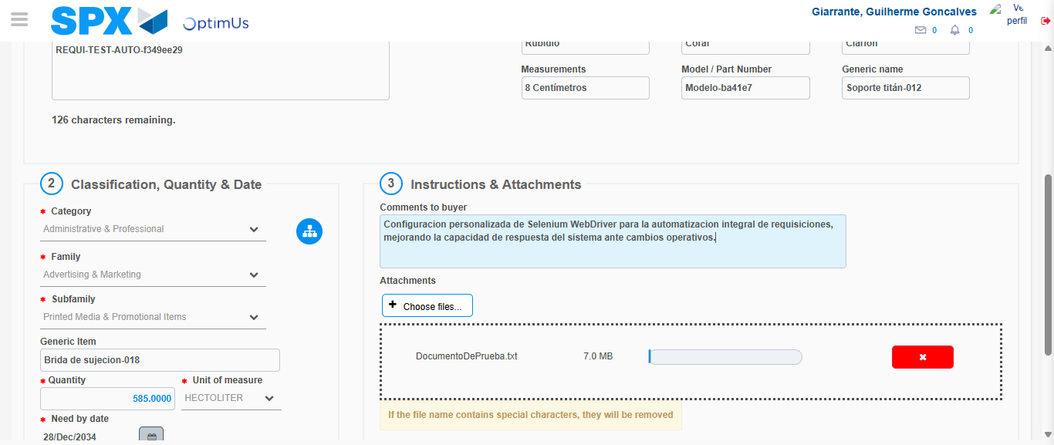Image file-name: QC_Testing-tc002_SPX_Dev5_Crear_Requisicion_Spot_Tipo_Cobro_Project-1784309970397

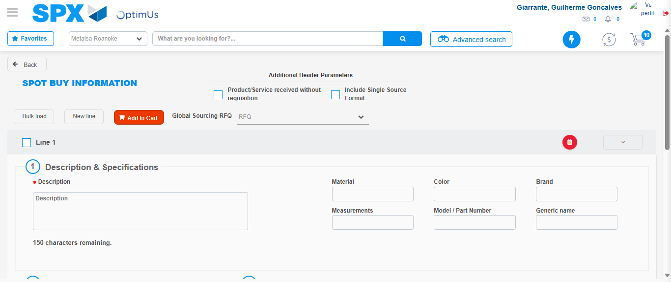Image file-name: QC_Testing-tc002_SPX_Dev5_Crear_Requisicion_Spot_Tipo_Cobro_Project-1784309976012

Step 7 - Return to Main Page SPX : Return to Main Page SPX
Image file-name: QC_Testing-tc002_SPX_Dev5_Crear_Requisicion_Spot_Tipo_Cobro_Project-1784309938927

Image file-name: QC_Testing-tc002_SPX_Dev5_Crear_Requisicion_Spot_Tipo_Cobro_Project-1784309941966

Image file-name: QC_Testing-tc002_SPX_Dev5_Crear_Requisicion_Spot_Tipo_Cobro_Project-1784309951386

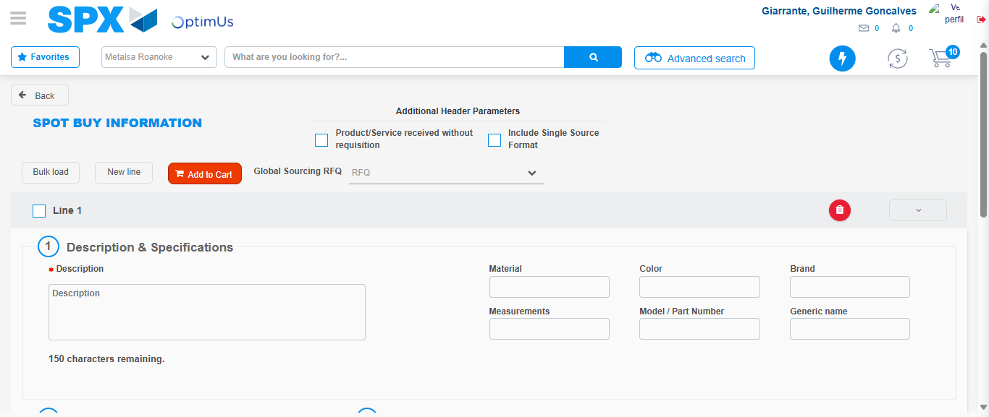Image file-name: QC_Testing-tc002_SPX_Dev5_Crear_Requisicion_Spot_Tipo_Cobro_Project-1784309978392

Image file-name: QC_Testing-tc002_SPX_Dev5_Crear_Requisicion_Spot_Tipo_Cobro_Project-1784309978697

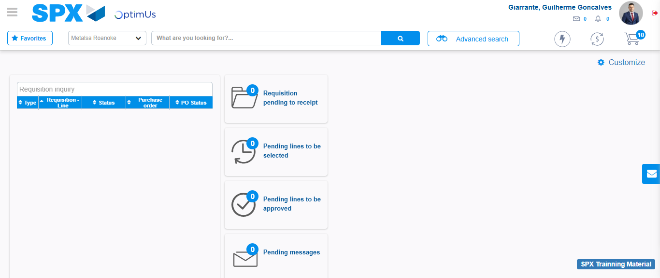Image file-name: QC_Testing-tc002_SPX_Dev5_Crear_Requisicion_Spot_Tipo_Cobro_Project-1784310000075

Step 8 - Log Out : Log Out SPX
Image file-name: QC_Testing-tc002_SPX_Dev5_Crear_Requisicion_Spot_Tipo_Cobro_Project-1784310000395

